# Lab: Reflection and Annotations

Problems for exercises and homework for the ["Java OOP" course @ SoftUni.](https://softuni.bg/trainings/2245/java-oop-february-2019)

You can check your solutions here: <https://judge.softuni.bg/Contests/1604/Reflection-Lab>

# Part I: Reflection

## Reflection

Import "**Reflection class**" to your "**src**" folder in your project. Try to use **reflection** and print some information about this class. Print everything on new line:

* **This class type**
* **Super class type**
* **All interfaces** that are implemented by this class
* **Instantiate object** using reflection and print it too

**Don’t change anything in "Reflection class"!**

### Solution

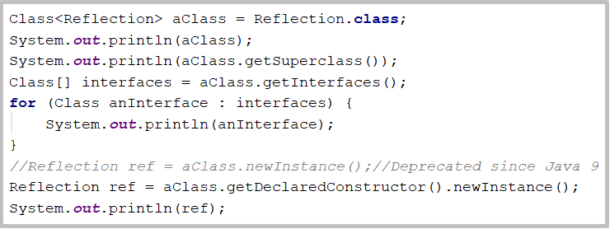

## Getters and Setters

Using reflection to get all "**Reflection** **class**" methods. Then prepare an algorithm that will recognize, which methods are **getters** and **setters**. Sort each collection **alphabetically** by methods names. Print to console each **getter** on new line in format:

**{name} will return {Return Type}**

Then print all **setters** in format:

**{name} and will set field of {Parameter Type}**

**Do this without changing anything in "Reflection class"**

## High Quality Mistakes

You are already expert of **High Quality Code**, so you know what kind of **access modifiers** must be set to members of class. Time for **revenge** has come. Now you have to check code produced by your "**Beautiful and Smart**" trainers in class **Reflection**. Check all **fields and methods access modifiers**. Sort each category of members **alphabetically**. Print on console all **mistakes** in format:

* Fields
  + **{fieldName} must be private!**
* Getters
  + **{methodName} have to be public!**
* Setters
  + **{methodName} have to be private!**

If you find more than **3 errors** go to your trainer and tell him "Your code is full of bugs. You don’t understand encapsulation man"

# Part II: Annotations

## Create Annotation

Create annotation Subject with a String[] element called **categories**, that**:**

* Should be available at runtime
* Can be placed only on types

### Examples

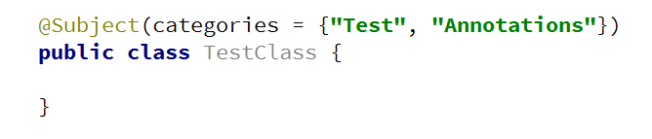

## Coding Tracker

Create annotation Author with a String element called **name**, that:

* Should be available at runtime
* Can be placed only on methods

Create a class **Tracker** with a method:

* static void printMethodsByAuthor()

### Examples

